SYNOPSIS OF CURRICULUM VITAE 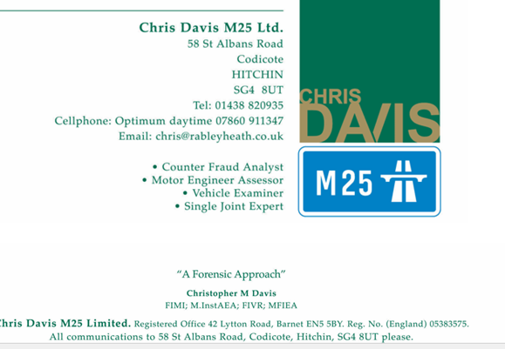

Fellow of The Institute of The Motor Industry
Fellow of The Institute of Vehicle Recovery
Member of The Institute of Automotive Engineer Assessors
Membere Federation Internationale des Expertes en Automobiles

1963 > 1986 Duties in Multi Franchise Dealership
Rising to Chairman

1986 > Current , Forensic Motor Engineer and Motor Claims Analyst
Specialisations : -
Acting and Reporting within CPR35 Rules
Advising The Nation’s Courts , Legal Profession , Insurers and other bodies on :
Aspects of Vehicles’ : -
DESIGN AND BUILD
FITNESS FOR PURPOSE
QUALITY AND ROADWORTHINESS
COLLISION DAMAGE DETAIL AND CONSEQUENCE
DAMAGE COMPATIBILITY / CONSISTENCY
REPAIR MODES AND QUANTUM
CONDITION AND VALUATIONS
ANALYSE CLAIMED CIRCUMSTANCES
COUNTER MOTOR INSURANCE FRAUD INVESTIGATIONS

Experienced in giving evidence in person in Courts, both Civil and Criminal

