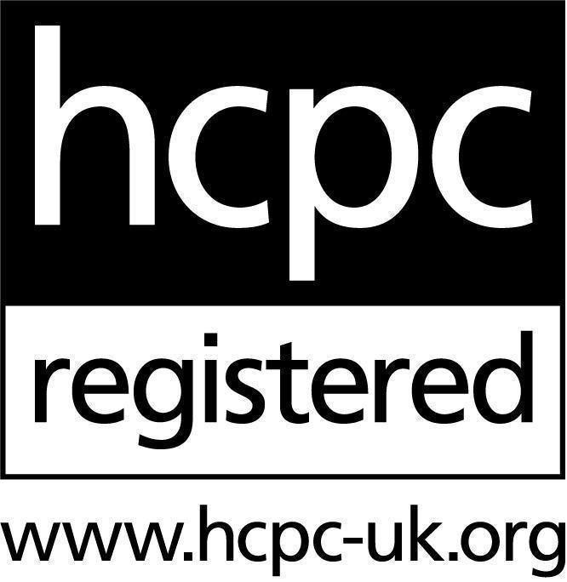
Dr Elizabeth Elliott
B.A, D.Foren.Psy, AFBPsS
Senior Forensic Psychologist

Health Professions Council Registration: PYL35355
I am qualified as a Doctor of Forensic Psychology, registered with both the HCPC and the British Psychological Society, with specialist expertise in the assessment and management of high-risk offenders in secure and community settings. Throughout my career to date I have developed extensive clinical experience across a variety of professional environments, including secure psychiatric units, police custody suites, private practice, court systems, and prisons. This breadth of experience has enabled me to collaborate effectively with multidisciplinary teams and to work sensitively with individuals from diverse cultural and clinical backgrounds.
I am proficient in the use of a wide range of forensic assessment tools, including those focusing on psychopathology, risk and threat assessment (stalking, domestic violence, terrorism and sexual offending), personality disorders and psychopathy, neurodevelopmental and neuropsychological functioning, child protection concerns, and response validity/malingering. My clinical approach is underpinned by a strong ability to build rapport and elicit meaningful, accurate information during psychological assessments, supported by rigorous forensic methods for the accurate collection, validation, and analysis of complex psychological data.
I established and lead the Health Trust’s quarterly Psychopathy and PCL-R Working Group and Stalking Working Group with links to the Metropolitan Police and forensic community services. In addition, I contribute specialist expertise to the Trust’s Seclusion Working Party. I have undertaken training and have actively participated in post-incident learning events and Critical Learning Reviews following serious incidents, including suicides and homicides.
I have co-developed and delivered autism training for inpatient mental health professionals across London in collaboration with the National Autistic Society and HCR-20 risk assessment training across the South London Partnership (SLP). I have also held an academic role as a Visiting Lecturer in Forensic Psychology at King’s College London and I am formally trained in Dialectical Behaviour Therapy (DBT).
I co-lead the South West London & St. George’s NHS Trust’s Sexual Behaviour (risk) Service (SBS) and have led in the development of a business case to secure increased staffing and funding in order to expand this across the SLP as a stand-alone provision that can also serve non-secure inpatient and community teams. Building a case for this Service has, so far, involved liaison with Finance and Strategy and presenting a case for change to the Trust’s senior leadership.

Academic and Professional Qualifications
2021 Bond Solon Expert Witness Certificate in Criminal Law, Cardiff University
2017 Professional Doctorate in Forensic Psychology, The University of Nottingham
2011 BA Psychology, The University of Sheffield

Employment History
2020 - Present Expert Witness in private practice (London, UK)
- Currently working through my limited company (Forensic Psychology Expert Ltd) as an expert witness for the Parole Board and Criminal and Family Courts across England and Wales.
- My practice focuses on clinical forensic assessment, particularly in regard to the assessment of risk, personality disorder, and sexual deviance. I have conducted hundreds of assessments for the courts and in consultation for mental health services, government agencies, and defence lawyers.
2020 - Present Highly Specialised Clinical Forensic Psychologist, Shaftesbury Clinic, Springfield Hospital (London, UK) (0.8 FTE)
- Clinical Lead for the Offending Behaviour Pathway within the inpatient forensic service.
- Completing specialist psychological and risk assessments of clients (often under the Ministry of Justice) receiving inpatient care across four forensic wards.
- Core member of the Medium Secure Multidisciplinary Team.
- Providing consultancy to non-forensic teams to support the management of service users presenting with behaviours of concern and inform decisions about gatekeeping and transfer.
- Interviewing and recruitment (Band 7/8a)
- Active member of the QNFMHS Review Team, reviewing forensic mental health service delivery on behalf of the Royal College of Psychiatry.
- Formulating and implementing plans for the formal psychological treatment and management of clients’ mental health problems and risk behaviours.
- Implementing a range of psychological interventions for individuals and groups in medium and low security.
- Providing specialist psychological advice, guidance and consultation to other professionals across the Trust and our partnership agencies.
- Co-lead for the Trust’s Sexual Behaviour Service.
- Providing professional and clinical supervision of trainee, assistant and Band 7 psychologists
- Delivering forensic training, reflective practice, and case formulation sessions to frontline staff
- Policy Development (e.g. authored and implemented a protocol for service user access to adult material)
- Leading training needs analyses across the forensic service
- Advising on both service and professional management on psychological and
clinical aspects of the service
- Lead and Coordinator of the Psychopathy & PCL-R Working Group for South West London St George’s Trust
- Lead and Coordinator of the Mental Disorder & Terrorism Working Group for South West London St George’s Trust

2018 – 20 Forensic Psychologist - Her Majesty’s Prison and Probation Service (London, UK)
- Testifying as a Professional Witness at Parole Board Hearings
- Completing risk and cognitive assessments using a range of psychometric measures
- Delivering consultancy to MAPPA, the National Probation Service and Segregation Units across London
- Advising Imprisonment for Public Protection (IPPs) Panels on steps for sentence progression
- Delivering therapeutic interventions to offenders with complex mental health needs
- Working in partnership with the Joint Extremism Unit (JEXU), attending and contributing to Pathfinder meetings, conducting specialist risk assessments for offenders convicted under The Terrorism Act.
- Fully trained and deployed as a hostage negotiation advisor to critical incidents across HMPPS. Trained officers in hostage negotiation alongside colleagues from the National Tactical Response Group.
- Complex case formulation to inform risk management decisions and plan interventions.
- Giving professional evidence at Multi Agency (Lifer) Risk Assessment Panels (MALRAP)
- Completing personality profiles for high-risk offenders to inform risk management and treatment
- Supervising trainee forensic and clinical psychologists
- Prison Safety and Violence Reduction Lead at HMP Wandsworth
- Conduct psychological assessments of prisoners on an ACCT

2015 – 18 Forensic Psychologist at Her Majesty’s Courts and Tribunals Service Together Liaison and Diversion Service (London, UK)
- Delivering oral and written risk assessments in a highly pressured and fast paced court environment
- Advising the court on the appropriateness diversion under the Mental Health Act
- Delivering training and consultation to Judges/ Magistrates, Legal Advisors and colleagues within the National Probation Service
- Completing complex clinical case formulations
- Supervising mental health nurses with the Liaison and Diversion Service
- Liaising with prison staff across HMPPS and the NHS in relation to prison transfers, mental health support, and risk management.
2014 – 15 Forensic Psychologist in Training - The Bamburgh Clinic NHS Medium Secure Unit at St Nicholas Hospital (Newcastle, UK)
- Practising as part of a multidisciplinary team (MDT) across four wards to provide psychological support and treatment to patients with significant forensic histories and complex mental health needs
- Clinical formulations and care planning
- Completion of discharge assessments for transfer into the community
- Conducted research under the supervision of Professor Don Grubin on the use of the polygraph in the risk management of sexual offenders
2013 – 14 Forensic Psychologist in Training - Forensic Psychological Services (Dublin, Ireland)
- Assessing and managing a caseload of suspects/offenders on bail or post sentence in the community
- Conducting detailed forensic risk assessments and cognitive assessments for a referred cohort of men associated with the Augustinian order of the Catholic Church, investigating historical allegations of sexual abuse within the Church.
- Some experience in the assessment of parental capacity, interrogative suggestibility and psychological fitness for offenders facing trial

2013 Kent Police Child Exploitation Investigation Team
Observational placement (4 months) for the Doctorate in Forensic Psychology
Assisting with data collection and entry for the Fighting International Internet Paedophilia project (FIIP)
Accompanied frontline officers during warrant executions, observing investigative procedures, inter-agency working, and safeguarding practices
Completed Achieving Best Evidence training
PACE training
Periodic attachment with the Crime Scene Investigation Team during suspicious death, rape and homicide enquiries (observational role)

Specialist Training And Expertise
- Assessment of psychopathology/mental health assessments
- Violence, stalking and sexual violence risk assessment and management
- Capacity to protect in non-offending parents
- Assessment of terrorism and extremism- related offences
- Personality assessments (personality disorders and psychopathy)
- Malingering
- Arson
- Non-accidental injury/ physical child abuse
- Online offending
- Assessment and treatment of paraphilic sexual interests
- Suicide and self-harm risk assessment
- Cognitive and neuropsychological assessment

Publications
Elliott, & Vollm, B. (2018). The Utility of Post-Conviction Polygraph Testing Among Sexual Offenders. Sexual Abuse, 30, 367-392.
Elliott, Egan, V., & Grubin, D. (2017). A Not So Bogus Pipeline: A Study of the Bogus Pipeline Effect and Its Implications for Polygraph Testing. Polygraph, 46, 1-9.

Memberships
Registered with the Health and Care Professions Council (HCPC)
Member of the Crime In Mind (CIM) Network

Chartered by the British Psychological Society as a Forensic Psychologist

Associate Fellow of the British Psychological Society

Continuing professional development (2021-2026)
- The Clinician-Administered PTSD Scale for DSM-5 (CAPS-5)
- Autism Diagnostic Observation Schedule, Second Edition (ADOS-2) and Autism Diagnostic Interview (ADI-R) training and Refresher training (Hogrefe)
- ADHD Diagnosis and Assessment training (UKAAN)
- Narcissistic Personality Disorder and differential diagnosis (3 day training, SDS Seminars)
- Malingering- The Structured Interview of Reported Symptoms, 2nd Edition (SIRS-2)
- Dissociative Identity Disorder (Australian and New Zealand Association of Psychiatry)

- The Gudjonsson suggestibility and compliance scales (Psychology Innovations Ltd)
- The Risk of Sexual Violence Protocol (version 2, Palo Alto University (PAU))
- Using multiple actuarial instruments in risk assessment (SAARNA)
- Assessing high- functioning autism in adults (Counterterrorism Long-Term High Security Estate)
- Terrorist Radicalization Assessment Protocol (TRAP-18) (The Global Institute of Forensic Research)
- The Psychopathy Checklist Revised (The International Organisation of Forensic Practitioners )
- Choosing, using and presenting psychometrics in court, British Psychological Society
- Incels, extremism and risk of violence towards women (The Forensic Psychiatry Institute)
- Child murder by parents (The Forensic Psychiatry Institute)
- Best Practices in the Assessment and Diagnosis of Compulsive Sexual Behaviour Disorder (CSBD) (The Forensic Psychiatry Institute)
- Serious violence and its relationship with adverse childhood experiences, Youth Justice Board
- Static 99R (SAARNA)
- Stalking & Harassment within an Ex-Partner Context (Centre for Action Against Stalking at the University of the West of Scotland)
- Individuals who have Sexually Offended with Neurodevelopmental Disorders (Elysium Healthcare)
- Working with Domestic Abuse: Learning from domestic homicide reviews (The University of Bedfordshire)
- Practitioner psychology, extremism, radicalisation and terror (BPS)
- Tackling County Lines Conference (National Crime Agency)
- Medication to Manage Sexual Arousal (MMSA) (Crime In Mind and Nottingham Trent University)
- Averting Targeted School Violence and School Shootings (National Threat Assessment Centre)
- Dialectical Behaviour Therapy Intensive Training (British Isles DBT)
- Practical Guidance for Practitioners Representing Victims of Modern Slavery (Garden Court Chambers)
- Parental Alienation in the Family Courts (Brunel University)
- Criminal Law and Procedure (Bond Solon)
- Excellence in Report Writing (Bond Solon)
- Working with and assessing complex PTSD, South West London St George’s Trust
- Understanding Extremism with a Mixed or Unclear Ideology
- Threat from right-wing extremism (JANES)
- NHS Management and Leadership Course (Managing Difficult Behaviours within Teams, Chairing a productive meeting, Developing a flexible approach to your leadership behaviours, Towards Anti-Racism).
- Writing an effective business case (NHS Elect)

Scheduled CPD:
Clinical Negligence Essentials: substantive legal principles and case law (14.05.2026)
Self-Initiated Terrorism, Prevent (10.02.2026)

